**Sign Hawk**

Communication with the hearing impaired (deaf/mute) people is a great challenge in our society today, this can be attributed to the fact that their means of communication requires an interpreter at every instance. According to WHO, around 5% of the world’s population – or 466 million people – has disabling hearing loss out of which 432 million are adults and 34 million are children. Around 3 million people in the world know sign language. We observe that there is a huge gap between the hearing population and non-hearing population. So, to bridge this gap, we aim to develop an AI sign language translator capable of translating sign language captured in a video to text as well as audio. The video provided to the translator can be an already recorded video or live feed from the camera.

**Features:**

* Translate sign language to text as well as audio.
* Translate from existing signs video.
* Translate live signs using a web-cam.

The proposed pipeline for translating sign language to text/audio is as follows:

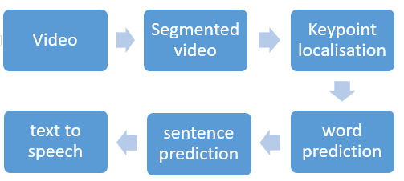

* **Video**: Sign language video.
* **Segmented video**: Video clips of different signs associated with different words.
* **Keypoint localisation**: Extracting positions of hand and arm key points from videos.
* **Word prediction**: Predicting word from sequence of position on hands and arms.
* **Sentence prediction**: Predicting sentences from the predicted words.
* **Text to speech**: Converting text to speech.

**Previous Works:**

* Kinect Sign Language Translator: It’s a sign language translator developed by Microsoft. It uses Kinect technology for 3D human pose estimation. This application is under development.
* Google is also developing a Sign language translation solution which uses 2D images from camera for pose estimation.

# **GROUP MENTOR**

Prof. Shilpa

Department of Computer Science and Engineering

# **TEAM MEMBERS**

**Group No. 33**

1. Rishi Dhawan (18103013)
2. Aryan Singla (18103062)
3. Manav Singla (18103065)
4. Suhel Naryal (18103092)